Apache Storm is a free and open source distributed real-time computation system. Storm is simple, can be used with multiple programming language such as Java, C#, Perl, Ruby. Storm is fast and is able to process maximum of million tuples per second per node. It is scalable, fault-tolerant, guarantees that data will be processed once and is easy to set up and operate. Storm makes it easy to reliably process unbounded streams of data, doing for real-time processing what Hadoop did for batch processing. Apache Storm is written in Java and Clojure. Storm has many use cases: real-time analytics, online machine learning, continuous computation, distributed RPC, ETL, etc.
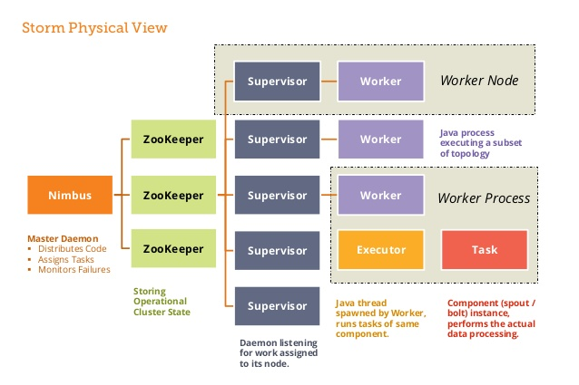
Storm Architecture:
Nodes -There are two types of nodes in Storm cluster.
Master Node(Nimbus): Nimbus is the master daemon and is responsible for distributing codes, assigning tasks to machines and monitoring their performance and failures.
Worker Node: Worker node also runs a daemon called ‘Supervisor’ which is able to run one or more worker processes on its node. Each supervisor works assigned by Nimbus and starts and stops the worker processes when required. Every worker process runs a specific set of topology which consists of worker processes working around machines
Storm Components:
Stream – A stream is an unbounded sequence of tuples. A tuple can be defined as the fundamental component in the Storm cluster containing a named list of the values or elements.
Spout – It is the entry point or the source of streams in the topology. It is responsible for getting in touch with the actual data source, receiving data continuously, transforming those data into actual stream of tuples and finally sending them to the bolts to be processed.
Bolt -Bolts keep the logic required for processing. These are responsible for emitting the streams for processing by other bolts and saving or sending the data for storage. These are capable of running functions, filtering tuples, aggregating and joining streams, linking with database, etc.
Topology – Storm Topology is the network made of spout and bolts. Spouts are the data stream source tasks and Bolts are the actual processing tasks. Every node in the network consists of processing logic’s and links to demonstrate the ways in which data will pass and the processes will be executed. Each time a topology is submitted to the storm cluster, Nimbus consults the supervisor nodes about the worker nodes.
Features:
- Storm integrates with multiple queueing system such as Kestrel, RabbitMQ / AMQP, Kafka, JMS, Amazon Kinesis.
- Processing data in real time.
- Integration with various databases, such as MongoDB, RDBMS's, Cassandra.
- Guaranteed Message Processing (at least once, exactly once).
- Able to Process maximum of million tuples per second per node.
- Fault Tolerant

